**sFirst Terminal Examination-2082**

**Class: Nursery Time :- 2 hrs. F.M.:50**

**Sub : English (O) P.M.:18**

1. How are you ? [5]
2. What is your name ? [5]
3. In which class do you read ? [5]
4. What is your class teachers name ? [5]
5. What is your favourite color ? [5]
6. What is your favourite vegetable ? [5]
7. Read the given letters. [5]

Aa Bb Cc Dd Ee

8 . Identify the pictures. [5]

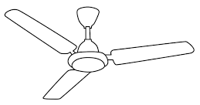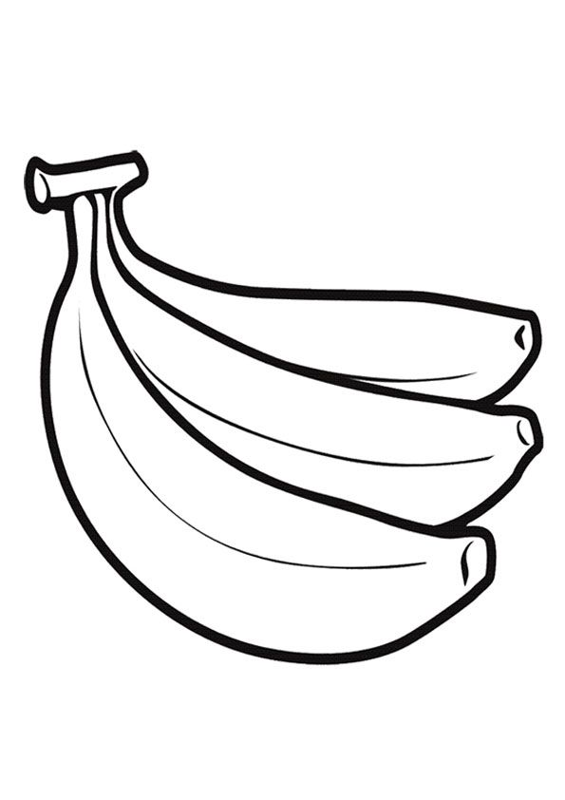

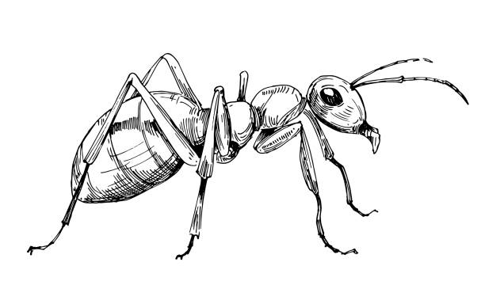

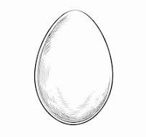

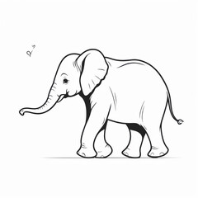

1. Neat and clean. [10]

**The End**